

**Name:** Harsh Vishwakarma

**Course**: B.Tech. C.S.E.

**Batch**: CCVT_B3

**Sap.id.:** 500119184

**Enrollment no.:** R2142230383

***LAB Experiment 1***

**Introduction to Java Environment**

**1. Explore and understand the role of JDK, JRE and JVM.**

**Ans:**

* **JDK (Java Development Kit):** It is a package containing tools for developing Java applications. It includes the JRE and necessary development tools like the compiler (javac).
* **JRE (Java Runtime Environment):** It is required to run Java programs. It contains libraries and the JVM but does not include development tools.
* **JVM (Java Virtual Machine):** It is responsible for running Java programs by converting bytecode into machine code.

**2. Install latest available JDK and verify the Java Environment.**

**Ans:** We will download JDK from the website. So I have chosen Oracle website And download the latest version of this.

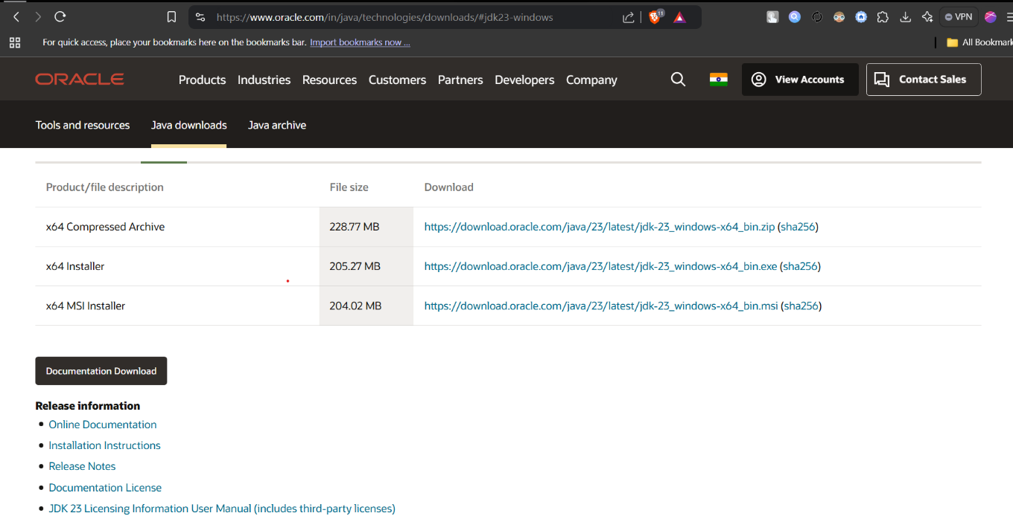

After this we will install the application and after that we will open Command Prompt and then We will enter some Commands in this.

>java -version  
>javac -version

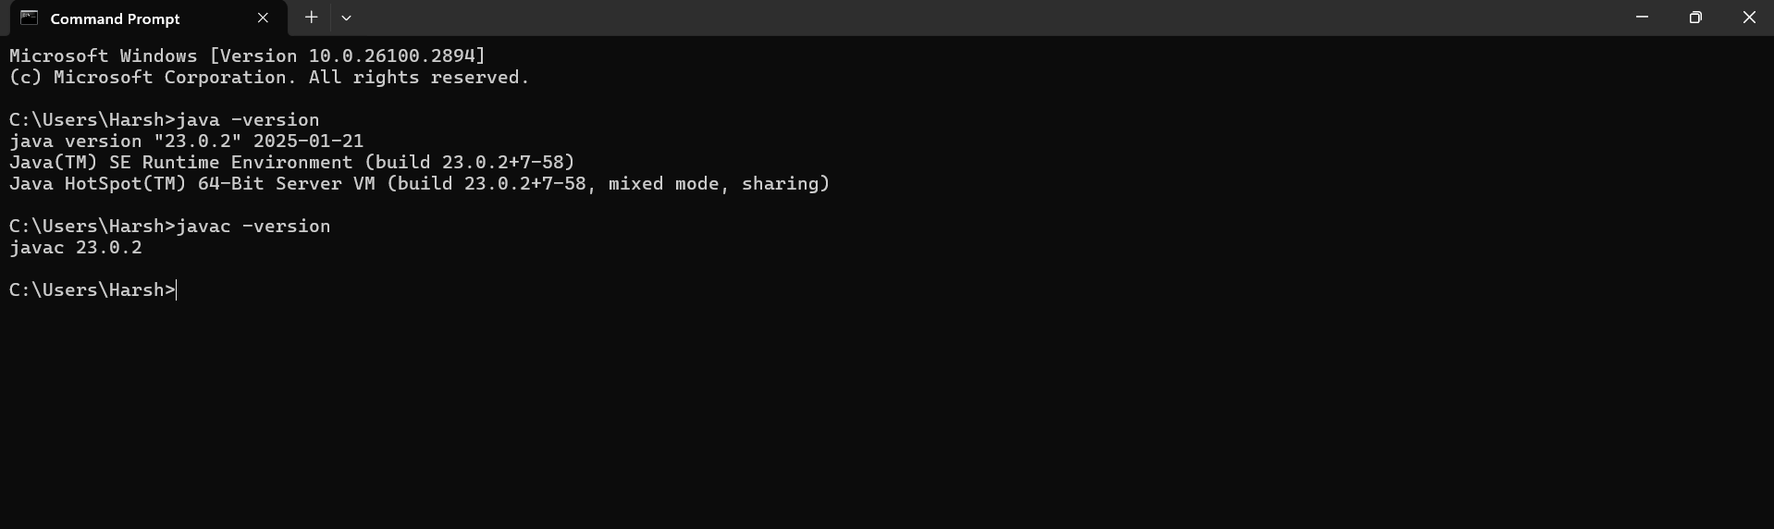

**3. Create a Sample Hello World Program using simple text editor (e.g. Notepad) and show the steps to compile and execute the program using command prompt.**

**Ans:**

We will open the notepad and then type the java code were we have to print the “Hello World” and then save it with enable ALL FILE option.

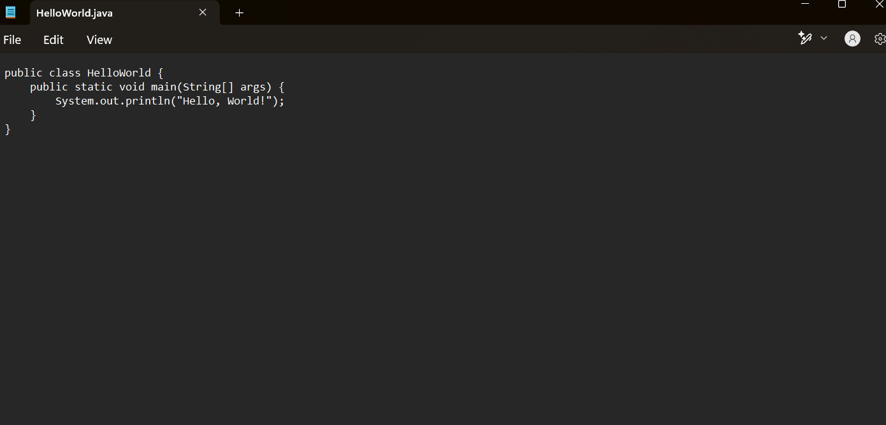

The we will locate the Path of that file and then we will open it in Command Prompt and we will run the code of that.

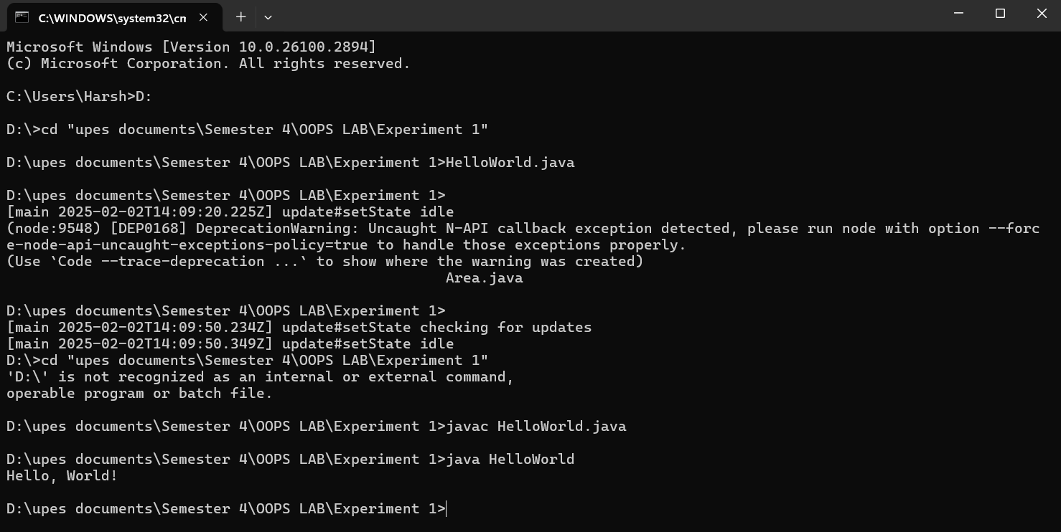

**4. Display your name and complete address in different lines.**

**Ans:**

I have Chosen Eclipse IDE and we will type the code for the Introduction in which we have to print My Information like Name, Sap id, Roll no. and City and State.

